39.50: a) Take the direction of the electron beam to be the x-direction and the direction of motion perpendicular to the beam to be the y-direction. Then, the uncertainty 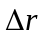 in the position of the point where the electrons strike the screen is
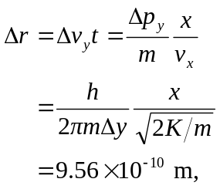
which is (b) far too small to affect the clarity of the picture.

